Charles Hesketh

Exam 3

**Problem 1:**

For one-factor-at-a-time we will use the recommendations of our “expert” to set initial values and then follow the given data to determine the best choices. Below we have the given data along with a column that shows, in numerical order, the path we took to obtain our optimum OFAT and a star in the column showing the true optimum value:

|  |  |  |  |  |
| --- | --- | --- | --- | --- |
| Oil Temp | % Carbon | Steel Temp | % of non-cracked Springs | Path/Optimum |
| 70 | 0.50 | 1450 | 67 | 1st and 2nd OFAT choice |
| 70 | 0.50 | 1600 | 79 | 3rd and final OFAT choice |
| 70 | 0.70 | 1450 | 61 |  |
| 70 | 0.70 | 1600 | 75 |  |
| 120 | 0.50 | 1450 | 59 |  |
| 120 | 0.50 | 1600 | 90 | * |
| 120 | 0.70 | 1450 | 52 |  |
| 120 | 0.70 | 1600 | 87 |  |

We were told to assume oil temp is the first important factor while fixing C=.05 and S=1450 yielding an oil temp of 70 and an optimum of 67%. Using O=70 and S=1450 we found C=0.50 with a percent optimum of 67% again. Using 0=70 and C=0.05 the optimum value that OFAT could find was 79% with S=1600, but the true optimum value is 90% found with the combination: O=120, C=0.50, and S=1450. This shows how OFAT can miss the optimum value based on bad initial values given by the expert.

**Problem 2:**

1. The given data was converted into 1 and -1 using the following scheme:

|  |  |
| --- | --- |
| **Data Point:** | **Number Converted To:** |
| A | -1 |
| B | 1 |
| Low | -1 |
| High | 1 |
| Y | -1 |
| Z | 1 |

From here the we developed a linear model through R where Avg. Response Time was the response variable and Flasher Type, Inertia of Lever, and Task were multiplied together. Looking at the estimates from this model we can find the value of the main effect by multiplying it by 2. Thus, the main effect of Task is 2.5*2=5.

1. Using a half normal plot we can see that Task is significantly far away from every other combination:

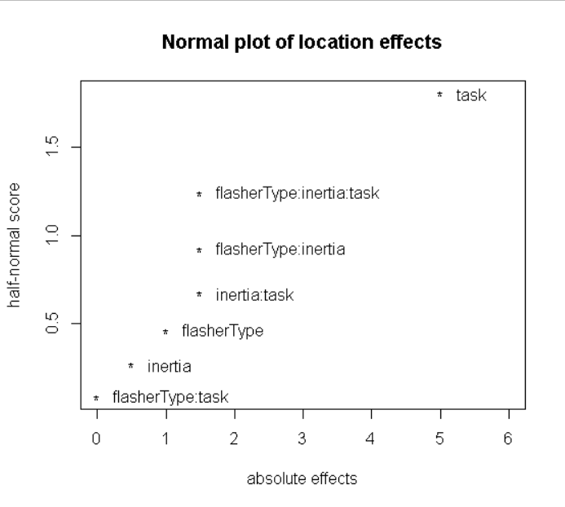

This suggests that Task is significant and we will use Lenths’ method to further investigate. Using Lenths’ method we get the following values for each effects:

|  |  |  |
| --- | --- | --- |
| **Effects:** | **Value:** | **Alpha=0.05 🡺 IER=2.3** |
| flasherType:task | 0.00 |  |
| inertia | 0.22 |  |
| flasherType | 0.44 |  |
| inertia:task | 0.67 |  |
| flasherType:inertia | 0.67 |  |
| flasherType:inertia:task | 0.67 |  |
| task | 2.22 | Not significant |

Based on the graph we would suggest task is significant; however, Lenths’ value shows it is not significant at alpha=0.05.

C) The variance of the main effect can be found by adding the high and low factors’ variance, which is determined by their day. Since 1-4 have a variance of 1 and 5-8 have a variance of 16, then

Vlow=var[(t2+t6+t7+t8)/4]=(1+16+16+16)/16=3.0625

Vhigh=var[(t1+t4+t5+t3)/4]=(1+1+16+1)/16=1.1875

**V**total=Vlow+Vhigh=3.0625+1.75=4.25

**Problem 3:**

1. Let S1 be the set {B1=123,B2=456,B3=167}, then we have a the following confounded interactions:

|  |  |
| --- | --- |
| Interaction | Results |
| B1*B2 | 123456 |
| B1*B3 | 2367 |
| B2*B3 | 1457 |
| B1*B2*B3 | 23457 |

The order of estimability is e=2 (see table in part C)

1. The table in appendix gives S2 to be the set {B1=1234,B2=1256,B3=1357} with the following confounded interactions:

|  |
| --- |
| Results from Table |
| 1234 |
| 1256 |
| 1357 |
| 1467 |
| 2367 |
| 2457 |
| 3456 |

The order of estimability is e=3 (see table in C) since g4>0 and g1=g2=g3=0.

1. The following table shows the calculated g for S1 and S2:

|  |  |
| --- | --- |
| S1: | S2: |
| g1(S1)=0 | g1(S2)=0 |
| g2(S1)=0 | g2(S2)=0 |
| g3(S1)=3 | g3(S2)=0 |
| g4(S1)=2 | g4(S2)=7 |
| g5(S1)=1 | g5(S2)=0 |
| g6(S1)=1 | g6(S2)=0 |
| g7(S1)=0 | g7(S2)=0 |

From this table we can see why e=2 given g3 is the first place we see a non-zero integer for S1, similarly for S2 having an e=3. From this table we see that we have given priority to the lower orders for S2, thus S2 is clearly the more advantageous blocking scheme by the Minimum Aberration Criteria.

**Problem 4:**

1. Multiplying both sides of 5=1234 by 5 and both sides of 6=124 by 6 we get I=12345=1264=356 and DCS={I,12345,1246,356}. This implies it has a Resolution III since the smallest word in DCS is of length 3.
2. Multiplying both sides of 5=123 by 5 and both sides of 6=124 we get I=1235=1246=3456 and DCS={I,1235,1246,3456}. This implies it has a Resolution IV.

The preferred choice is ii since it has a larger Resolution, III<IV, by the Maximum Resolution Criteria.

|  |  |  |  |  |
| --- | --- | --- | --- | --- |
| **Fr:** | **I=1235** | **I=1246** | **I=3456** | **Clear** |
| **12** | 35 | 46 | 123456 |  |
| **13** | 25 | 2346 | 1456 |  |
| **14** | 2345 | 26 | 1356 | * |
| **15** | 23 | 2456 | 1346 |  |
| **23** | 15 | 1346 | 2456 |  |
| **24** | 1345 | 16 | 2356 | * |
| **25** | 13 | 1456 | 2346 |  |
| **34** | 1245 | 1236 | 56 | * |
| **35** | 12 | 123456 | 46 |  |
| **45** | 1234 | 1256 | 36 | * |

The last column labeled Clear marks the 2-fis that are clear and, thus, estimable. Since we can ignore 2-factors that involve 6 and any aliases that are greater than 2 are negligible these are the clear factors. To list, these are 14,24,34,45.

|  |  |  |  |  |  |  |
| --- | --- | --- | --- | --- | --- | --- |
| **Fr:** | **I=1235** | **I=1246** | **I=3456** | **MF Present** | **Pair A (134)** | **Pair B (136)** |
| **123** | 5 | 346 | 12456 | * |  |  |
| **124** | 345 | 6 | 12356 | * |  |  |
| **125** | 3 | 456 | 12346 | * |  |  |
| **126** | 356 | 4 | 12345 | * |  |  |
| **134** | 245 | 236 | 156 |  | * |  |
| **135** | 2 | 23456 | 146 | * |  |  |
| **136** | 256 | 234 | 145 |  |  | * |
| **145** | 234 | 256 | 136 |  |  | * |
| **146** | 23456 | 2 | 135 | * |  |  |
| **156** | 236 | 245 | 134 |  | * |  |
| **234** | 145 | 136 | 256 |  |  | * |
| **235** | 1 | 13456 | 246 | * |  |  |
| **236** | 156 | 134 | 245 |  | * |  |
| **245** | 134 | 156 | 236 |  | * |  |
| **246** | 13456 | 1 | 235 | * |  |  |
| **256** | 136 | 145 | 234 |  |  | * |
| **345** | 124 | 12356 | 6 | * |  |  |
| **346** | 12456 | 123 | 5 | * |  |  |
| **356** | 126 | 12345 | 4 | * |  |  |
| **456** | 12346 | 125 | 3 | * |  |  |

From columns Pair A and Pair B we can see the 3-fis that are not aliased with MF or 2-fis. Selecting one value from either Pair A or from Pair B, for instance B=134, will create a design with design generators 5=123 and 6=124 and block B.

**Problem 5:**

Since we want to do a 2­­8-2 design, then our k=8 and our p=2. Since we want 16 runs a day, then our blocking will need to be 4 (since 28-2=64 and 64/16=4) thus 22=4 implies q=2. Referencing our table we should select a design such that the generators are 7=1234 and 8=1256 with block generators B1=135 and B2=246. Choosing this design gives us all 28 2-fis as clear which is the most desirable design and the reason it was chosen.